*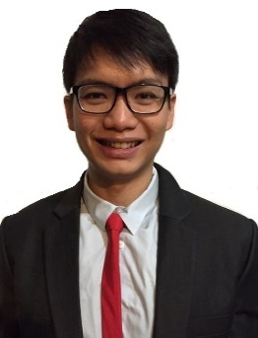Curriculum vitae* **Low Wei Jun**Address: 48 Jalan Novena, Singapore 308666

Date of Birth: 7 May 1991  
Nationality: Singaporean  
Mobile: +65 91739032  
Email: [lowweijun@hotmail.com](mailto:lowweijun@hotmail.com)

# **Education**

**University of Queensland** *February 2014 – July 2015*

Bachelor of Commerce, major in Accounting

**Nanyang Polytechnic**  *April 2008 – March 2011*

Diploma in Business Management, major in Customer Relationship Management

# **Work Experience**

**Partners Group AG***Fund Accounts Assistant November 2015 – July 2016*

* Managed full set of accounts for 8 private market funds (equity / infrastructure / real estate)
* Prepared the monthly/quarterly/annual closing including bank reconciliation, income and expense accruals/prepayments, manage payables/receivables, stock and blocker distributions, hedges position
* Analysed LPAs/side letters to interpret relevant fee calculations for management fee and rebates, etc
* Serviced monthly/quarterly product compliance checklists with proper documentation processes
* Reviewed key figures on Capital Accounts Statements as well as net TVPIs and IRRs on fund level
* Assisted with audit requirements, additional customized reports, and managed external client requests

**Unigestion Asia Pte Ltd***Middle Office – Fund Analyst*  *August 2016 – Present*

* Receive reports from the various Fund’s General Partner to input key figures into eFront
* Analyse quarterly variations and perform reconciliation of the every company’s positions in each fund
* Provided support on the audit requirements which includes finalizing of the underlying fund’s NAV
* Liaise with underlying funds’ CFO/GP/Administrator on obtaining certain disclosures from the report

# **Other Qualifications**

**Project Management Institute**   *2013*

- E-Learning course on Project Management

**Ikoma Language School**  *2014*

- Intermediate Japanese Language Course

# **Skills**

**Software skills**:

- Microsoft Office; eg. (Excel, Powerpoint, SharePoint, VBA, HTML, Outlook), Abacus, eFront, Siebel

**Language skills:**

- English, Mandarin, Elementary Japanese, Basic French

# **Hobbies**

- Traveling, Hiking, Soccer, Trading, Movies, Indie music, Crossfit